**ABSTRACT**

This project highlights the need in the Nigeria fashion industry for efficient tailoring services for traditional attire. I propose an online portal that allows clients to design clothing by selecting their preferred fabric and style. This process removes the apprehension from choosing fabric and dealing with tailors.

Tailors are notorious for their inconsistency and missed deadlines, but there are a lot of dedicated tailors in Nigeria. T he challenge is getting to them. Explain. **Suave Stitches** uses new technology to identify high-quality, dependable tailors who offer clients ….

CHAPTER ONE

**INTRODUCTION**

**Science**

Science is a discipline of learning which deals with measurable or systematic principles. It does not rely on intuition or natural ability. Science can be described as a body of knowledge that deals with established facts or the acquisition of these facts.

Science has come a long way from the times of Thales and Socrates to the smart devices we have today.

**Science and Technology**

Technology comes from the Greek word *techne. Techne* is the name for the activities and skill of the craftsman as well as arts of the mind and fine arts. Associated with t*echne* is the idea of bringing forth or making things. Today this idea extends to manufacturing.

For my purposes here, *techne* can be defined as the collection of tools - including machinery - modifications, arrangements and procedures used by humans.

Technology alters the way humans relate with their environment. It offers a means of controlling some aspects of the environment and this enhances the survival of the human species.

Technology broadly can be described as applied science or the practical application of knowledge, so it is the point where science comes alive. For instance, after research is done to find active natural ingredients that can inhibit the spread of a certain bacteria in the body, this active ingredient is then synthesized in the laboratory so it can be mass produced for greater good and also for profit. The whole process is underpinned by science. So we can see that science enhances lives and also provides personal benefit to the custodian of certain knowledge.

**Consequences of Technology**

As well as bringing enhanced quality of life and standard of living, technology has its negative side. We are all too aware of the effects of nuclear weapons detonated in any geographical area. Nuclear power plants, and their spent uranium rods disposal problem. The rate of death from obesity primarily caused by engineered foods. Technology creates power that can sometimes be misused: the Nazi economy was highly mechanized and efficient, but it was effective in enabling its masters to commit unspeakable atrocities.

There is also the risk that comes with over reliance of technology, despite the fact that some of today’s shiny technology only offers incremental benefits, like ubiquitous Smartphone and their endless supply of games that leaves you struggling to justify the amount of time spent on them. It is not all bad we do have very advanced research like stem cell research that promises better medical care for humanity.

**Science and Technology in Africa**

It is true that Africa played a pivotal role in the historical development of science. The Egyptians had elaborate systems for mathematics and trigonometry. T, this was essential to the building of the pyramids. The Yoruba and Benin kingdoms in Nigeria had civilization with clear leadership and matured societies.

Egyptians charted the movement of the sun and constellations and the cycles of the moon. They divided the year into 12 parts and developed a yearlong calendar system containing 365 ¼ days. Clocks were made with moving water and sundial-like clocks were used.

The slave trade in Africa severely disrupted technological progress in Africa. It is well documented that it caused significant reduction in the population and hence a reduction in the talent pool on which science would have flourished. Cite your sources.

**Technology in the 20th and 21st Century**

Technology in the 20th century advanced so rapidly, first with the invention of distributable electricity, airplanes paving the way for more inventions and the expansion of man’s thinking to the possibility of technology and science. Modern trains, steel ships, and better health care. At no point in history has it been better to be a human because of this advancement, but sadly it makes armed conflicts more ferocious and deadly.

All this technology combined makes for improved standard of living, there is also a shift in culture. In the past most people worked and lived off their farms but today farming is practised on an industrial scale, and a lot of people who would have been farmers migrate to the city to look for work in factories..

The most notable improvement in technology of the 21st century is the rapid advancement in computer, fuelled by the invention of transistors, thus making computing devises smaller and powerful. This lead to the rise of the portable computing devices like laptops and smartphones, and the internet, that is underpinned by massive data centres around the world.

**Technology and Business**

The internet has changed the way business is done, it has brought in new players in most industries, and killed off old ones that failed to adapt or adapted slowly. With your internet connection you can work from anywhere in the world, communicate with people half way across the world without having to set up expensive infrastructure.

In the past, modern technology was not common place in businesses beyond the accounting department and other departments that require computation for huge data. Fast forward to today, security of data of all kinds is part of business strategy, and not just in technology companies, but also companies in different fields.

The rise of the remote workers is accelerating, instead of companies employing unskilled workers for jobs that require little training, and incurring huge overhead along the way, they outsource the job to contractors who are paid by the hour. This style has become widely used because it is considered to be cost effective and flexible: firms only pay for the services rendered and no more. Outsourcing jobs can also increase the pool of talented workers available to anyone that require such services, for instance, most Nigerian banks have their web interfaces built in India or other countries where they have a huge pool of advanced technical workers.

This new concept along with the popularity of the internet has created legions of entrepreneurs whose business models are solely reliant on the internet with very little physical presence. It has made setting up businesses easier.

With an app built by a freelance developer, you assemble freelance workers, from data entry clerks, accountants, to business developers and virtual assistants. With this you can quickly test your business model/idea to see if there is a market for it, from there you can build out a standard company, or you kill it off if you don’t gain traction, without having to deal with huge rent, and loads of legislation, laying off staff is as easy as clicking a button to end contracts over the internet.

In the technology industry, the implication of virtual workers for businesses of any size is profound, by sharing the service of highly skilled workers they hence share the cost of such highly specialised skills and still get quality services.

CHAPTER TWO

**PRODUCT**

**2.1 The Problem**

Sometimes we all need bespoke outfits for special occasions. T his is especially true for Africans, who like to show their deep cultural heritage, rich background and history. no matter their place of residence around the world, they like to have specific garments available, just as they long for traditional meals even in the Diaspora. I have knowledge of a hair stylist in Nigeria recording her work on video that will be sent to London, so it can be replicated by another hair stylist over there.

In Nigeria, especially Lagos, most professionals are short on time; they have to deal with heavy traffic to and from their destinations it is estimated that Lagosians spend anywhere from 20 minutes to 1 hour at the bus stop(cite). This situation means less time to spend with family and fulfil other social obligations. This class of people are the demographic that is targeted by Suave Stitches. They have disposable income, but lack the time. We all know how online grocery shopping saves time and resources that is the same convenience that we offer. Make a direct comparison to an existing online grocery here.

Clothing plays an important role in African culture

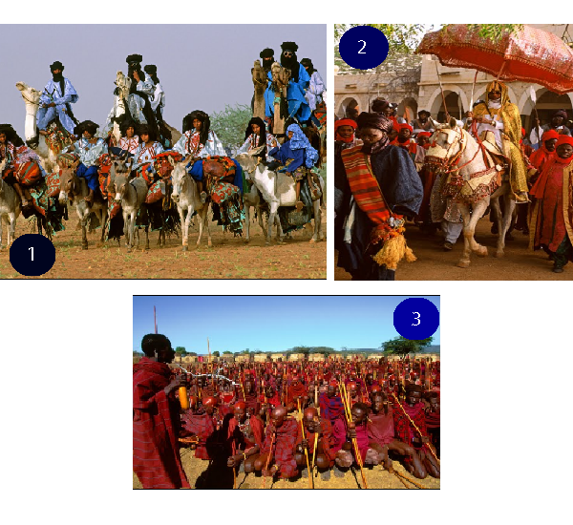

**1** Arrival of Taureg Guest at a wedding, Mali

**2** Emir of Kastina, at Sallah Kastina State, Nigeria

**3** Massai warriors initiates receiving Elders Blessing, Kenya

Given the rowdy nature of most Nigeria’s markets, it is usually an unpleasant place to visit. There is nothing like leisurely browsing the aisles because they are disorganized. Most people avoid them if they can (?)they are rather avoided unless for important reasons.

**The entrance to a typical Nigerian market**

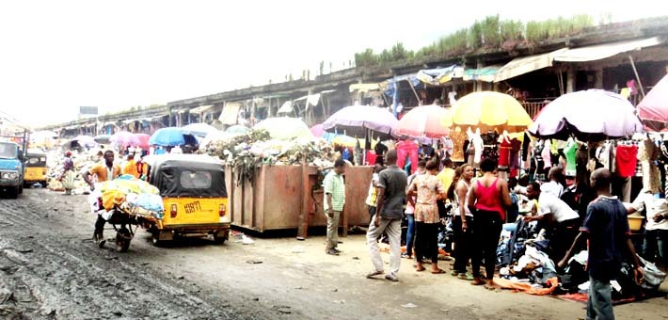

Speaking of getting a good tailor is a shoot and miss experience. Due to lack of strong laws, there is little relief for contracts gone sour, getting your money back is not worth the effort, and the fabric is wasted. Prospective clients of these fashion designers ask around for recommendations. this informal way of getting recommendations is not helpful as it can be biased When they do get the reviews, and settle for their choice of tailors, clients have to deal with the expectation of disappointment, missed deadlines, and little excuses that only means more dashed hopes

Most individuals have been burnt by these tailors and have mostly given up on local tailors.However, the skills and knowledge of the tailors are unique and cannot be replicated by industrialized processes or foreign designers. This is because their work is not repeatable and the need to adapt to different styles, not for a season or fashion trend, but from client to client. Technology has not caught up to replace tailors, most garments on sale in the west, from high end stores, to the cheap knock off in supermarkets are sewn by hand abroad, some of them in countries with little regard for workers safety.

**Attending an occasion without the right attire is frowned upon**

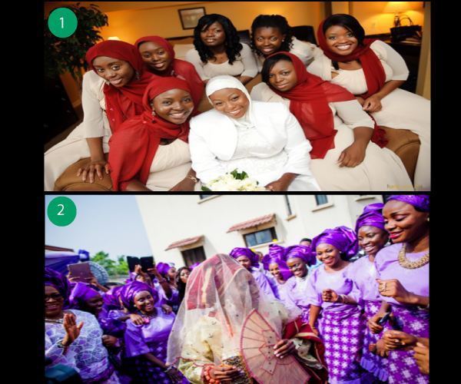

**1** Muslim wedding bride girls, Nigeria

**2** Yoruba traditional wedding, Nigeria

Most people have no choice but to deal with this tailors or fashion designers, because all the occasions and ceremonies attended by Africans have very specific guideline or expectation on the outfits to wear. Also in most African cultures, social status is directly tied to your clothing guests at an event will be seen as anomalies, if they show up with outfits outside the recommended style and fabric

So everyone has no other option but to keep trying different fashion designers, with different results.

**2.2 Market Analysis Summary**

Based upon the points made above about the ever-present demand for bespoke clothing, I believe there is a market to capture here. It is part of culture in Nigeria that almost every woman from the Southern part of Nigeria buys very large boxes immediately after her wedding. This box serves as a repository of traditional clothes that will be acquired going forward. This demographic is huge, and they are not the only ones that need this service, Traditional fashion is steadily rising in popularity in Nigeria. This is happening because of the realization that Nigeria’s many problems cannot be resolved by imitating solutions that worked in the west.

We are not quite there, but it is not out of place to see events that celebrate indigenous achievements. This trend has not permeated into every aspect of our socio-economic life, but at least it is happening in the area of arts and culture. It is not unusual to find young men who preferred western style clothing in the past to go for traditional attires. Explain more.

The following are some of the reasons for using an online platform for tailoring needs.

* It comes with a Fabric section to pick desired fabric.
* It is a one stop shop for all fashion needs.
* Transparency of design process, hence peace of mind.
* 100% Money back guarantee that is unavailable elsewhere.
* Flexible delivery, no need to visit tailors regularly to ensure that your order is being fulfilled.

**2.3 The Solution**

Suave Stitches will offer fabric and tailoring services online, the services can be broken down into the following:

* Selection of preferred fabric
* Selection of desired style
* Delivery

Basically, a web interface as the front end, to do the following

1. Enable clients select their preferred fabric, if it is available.
2. The option of providing their choice.
3. Give them a wide choice of styles to choose from.
4. Have the option of requesting bespoke design.
5. Providing a medium to take body size measurement.
6. Give estimated time of completion.

**Elaborating on the above points**

1. There will be a few partners (sellers of fabric), that we can catalogue their inventory. And have that on the website along with thumbnails, descriptions of the texture and other things. So clients can make an informed choice that meets their expectations and requirements.
2. Provision will also be made for clients who require specific services, like those going for uniforms to be used for ceremonies, the fabric will be arranged to be delivered to the tailor through a courier service.
3. A collection, in pictures of the most popular styles of the day, and with popular retro styles that are still cool. This will be combined with some offbeat styles for those that prefer such styles.
4. If the preferred style of a client style is not available in the database for any reason, the system will be flexible enough to make provision for such clients by allowing them request custom styles. They can upload pictures of the style, along with descriptions and references to other styles.
5. Body measurement is very necessary for this system to function properly; the default measurement will be international sizing charts for men and women. If the chart is not adequate, there will be instructions on how to take personal size measurements. Standards required for clothing include, top of shoulders, bust, waist, hips, inside legs and calf.
6. Estimated style of delivery will be calculated by the system after an order is processed by our algorithms. This will happen instantly and will be based on pre-existing orders. Optionally clients can choose our premium service that pushes their order to the top of the queue. Delivery for the premium services will range from two working days to five.

**CHAPTER TREE**

**METHODOLOGY**

A critical assessment of the features shows that the system’s building blocks will be similar to an online shopping store, howbeit a more complex one

The table below illustrates the similarities.

|  |  |
| --- | --- |
| **Store Shopping Store** | **Tailor System** |
| Select choice of product | Select choice of fabric |
| Select choice of colour or size | Select preferred style |
| Choose preferred shipping method and get estimated time of arrival | Get estimated time of delivery |

The differences are as follows

1. The clients decide that they want to use fabrics they bought, hence triggering the module to have fabric delivered to us.
2. When the required measurement for the client is unknown, they might have to source for it manually by physical measurement.
3. The method of calculating the delivery date is complicated because we have to consider the orders that are at hand, unless there is kind of an express service, although the commitment for that will be quite daunting.

The new programming concept that I have learnt over the past quarter, talks about breaking down your problem into smaller units, then find out is those smaller units have been solved by others. If solution is available or open source there is no need to reinvent the wheel, just incorporate it and then go on to solve the custom problems you have. This approach makes sense, it is a waste of effort to build everything from scratch, and you might get distracted with the minor details and miss the bigger picture. That will be the approach to building this tailoring system, faster development time means you can start testing the idea quickly.

**2.1 Investors**

The developed countries have done a good job in trying to harness the benefits of technology, but lately Nigeria is rising, we do have a co-working space (CC-Hub) with a technological flavour. That was unthinkable in the past, and foreign investors are taking note of this progress.

I think the biggest hindrance was the late entry of mobile communication technology. Nigerians are still grasping the impact of technology on the economy, or as a tool for personal development.

Recently there has been a lot of clone of foreign apps and technology business models in Nigeria, the prospect of success for such products are at best slim. Nigeria and her people have a different historical experience from the countries where these products were designed. The solution to Nigeria’s many failings does not rely solely on the internet or modern computing technologies.

If the solution to any indigenous problem lies in modern computing technology, then the solution should be crafted specifically to suit our society, rather than a one sized fit all approach.

This project, as mentioned earlier, fits into the category of solutions carefully designed to enhance the experience of people when they have to get traditional attires.

It is not all gloomy for Nigerian technology entrepreneurs, sites like konga.com, olx.com are changing our expectations of the shopping experience, indirectly making us demand better deals from salesmen on the street in an otherwise opaque transaction system where buyers have no knowledge that they can get better deals elsewhere.

The following are potential investors:

**The Tony Elumelu Foundation:**

The founder Tony Elumelu is a Nigerian businessman turned angel investor. His foundation are currently running a programme that encourages entrepreneurs to apply for funds Africa-wide. The programme runs for two months and ends in March. there is no limit to the kind of ideas that will be accepted. I believe this project is a good fit for the kind of ideas that is needed that is solutions that were conceived as a direct consequence of the challenges facing our immediate environment.

**iDEA Nigeria:**

IDEA (Information Technology Developers Entrepreneurship Accelerator) provides essential support to entrepreneurs to build software skills, solutions and businesses critical to their success. Entrepreneurs accepted into iDEA receive support in the way of physical work spaces, shared facilities, training, mentoring and access to capital.

**2.2 Social Implication**

The social implication is difficult to gauge, given the lack of data on total amount individuals spend on clothing yearly, and the time and effort it takes. I think the trend mentioned above, the perception of that indigenous arts and culture is not out of place in our contemporary world is rather strong. Nigerians and indeed Africans know that westerners appreciate Africa’s rich heritage and it is rubbing off on the way indigenous arts and culture is perceived today.

**2.3 Challenges**

1. **Tailor insincerity**

Nigerian tailors are notorious for their unreliability and known for their dishonesty. This is the biggest challenge … this is likely the biggest problem a system like this will face. Getting them to sign up for the system and to deliver on time would be a challenge. One way to go about it would be bargaining power we have, that is the prospect of the large number of client which will mean continuous business relationship with the tailors. In other words the possibility of regular contract will be an effective tool to ensure they strive for perfection.

1. **Unawareness of technology’s benefit**

Although Nigeria has a high penetration of [1]mobile computing devices, there is little knowledge of ways to leverage technology for personal development and economic gains. This will be an impediment to any technology company. The way out is to do your best and wait for technology to gain root, for people to learn to trust it, and see its tremendous benefits.

**CONCLUSION**

There is promise for this project, like most idea or solution it will be slow to gain traction, but with time things will smoothen out. There is so much potential in the niche and demand is inexhaustible.

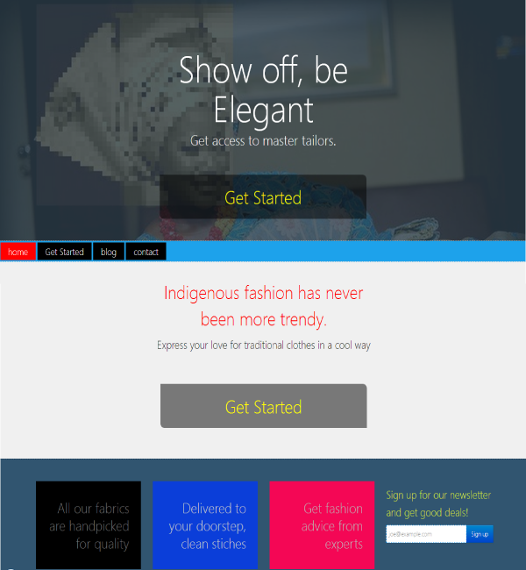

**REFERENCEs**

<http://www.nairaland.com/1955899/nigerian-tailors-disappointment-share-experiences>

**How Tailors Can Change Their Attitude And Make Millions**

<http://www.wealthresult.com/2014/05/how-nigeria-tailors-can-change-their.html>

<http://www.nairaland.com/1927087/aba-made-shirts-best-tailors-nigeria>

<http://www.smallbusiness.co.uk/running-a-business/office-and-home-working/2453297/the-remote-entrepreneur-running-a-successful-business-from-the-middle-of-nowhere.thtml>

<https://www.google.com/culturalinstitute/exhibit/african-ceremonies-passages/QQJgfgg2?hl=en&position=54%2C30>

<http://www.slideshare.net/jobberman/nigeria-employee-salary-survey>

<http://www.tonyelumelufoundation.org/teep/tony-elumelu-entrepreneurship-programme-gets-5000-applications-3-weeks/>

Fashioning Africa: Power and the Politics of Dress – *Jean Allman*

Traffic Management Problems in Lagos: A Focus on Alaba International Market Road, Lagos State Nigeria

*Olaogbebikan Jimoh Eniola, Ikpechukwu Njoku, Akinsulire Esther Seun and Enosko Okoko*

*Transport Management Technology Department, Federal University of Technology, Akure, Nigeria*

1. Nigeria has highest mobile phone penetration in Africa; you will hardly find anyone without one. Beggars on the street do have a mobile phone.